**2.2 Requirements Specification**

This is the section of the report that contains all of the requirements that should be implemented on the verification/testing and design of the end product.

**2.2.1 Problem Domain Description**

This section of the report is to trace the current business practices. The reason why defining the problem domain is important is because it helps the analyst to properly understand where the core problem lives. The solution can only be devised after the problem domains have been identified. Similarly, for this course record management system, first we will be identifying the problem domains and then solutions will be made.

**2.2.1.1 Existing Business Operation**

The activities that a business engages on the daily so as to increase the value of the enterprise is known as Existing Business Operation.

**2.2.1.1.1 Student Life-Cycle**

At first, the students write an enrollment form to apply to the university. The admission team will then check his/her application. If the application is accepted, there will be conditional and unconditional offer. Unconditional when the student has the required grade and conditional if the student does not have the required grades. The case papers containing all the information is created and stored in a provisional filing cabinet.

Then the grades of the entrance are released and sent to the university. If the student passes, they get a letter of offer from the university. It can be changed into unconditional if necessary.

If the student accepts the offer, they are enrolled into the course by the university. Their student information files will be created and then stored in a live cabinet with live headings.

When the student passes the course, their case paper is updated with the certification of the course that they completed along with the time duration. If the student fails or leaves the course then their case papers are closed.

All these papers of passed students, failed students, students who have applied for the university, students who have declined the offer letter sent by the university are kept recorded. They are kept in a dormant cabinet. The university then keeps these records for future references for the next 10 years.

After the 10 years have been completed, these records are then destroyed.

**Fig: Student Life-Cycle**

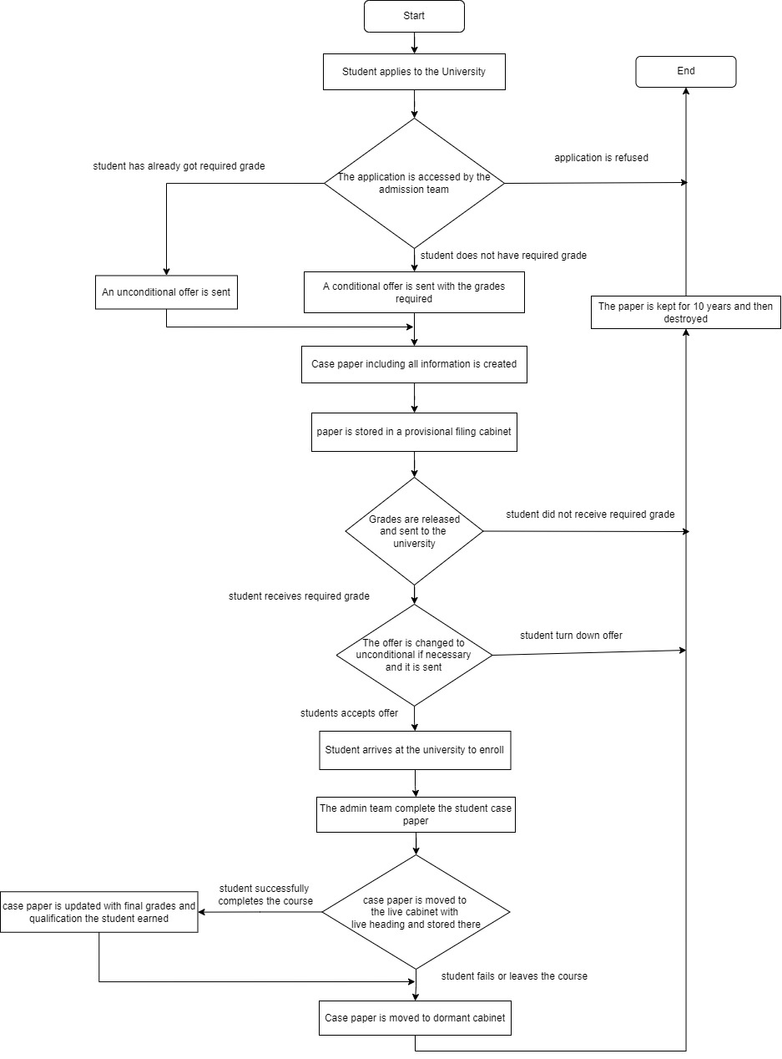**2.2.1.1.2 Personal Tutor Life-Cycle**

According to the interview findings, those students who want a personal tutor will first write an application to the administrator. The admin will then review their application to see the student’s reason for wanting a personal tutor.

Then the admin will check the availability of the existing tutors. If he approves the application and finds a tutor that is available then he will assign that tutor to the student.

If he does not approve the application or there isn’t any tutors that are available at that moment, the student’s application will be declined and they will have to write another application of the same sort on a later date.

**Fig: Personal Tutor Life-Cycle**

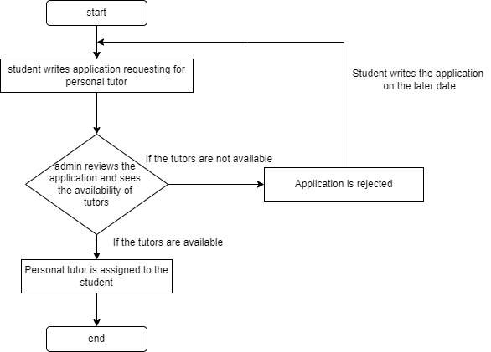

**2.2.1.2 Summary of existing business requiring resolution and existing strengths**

Some of the existing business problems are:

* Security issue

Because everything is paper based, the records can easily be lost, damaged or even stolen. So security is a big issue.

* High Cost

Paper based management means the business needs a lot of manpower to keep those records in place and in order.

* Storage

There is only so much a business can stored the records of when the entire record management system is paper based. So, storage is a common issue.

* Tedious work

Whenever someone want to view something about the students or the staffs, they will have to manually search for the files which is very time consuming and tedious work.

Also, some of the strengths of having a paper-based record management system are:

* Handling such records do not require a highly qualified manpower.
* Reproduction of the copies is easy due to the use of photocopy machine.
* If the documents are required by the law, then paper-based systems are very useful.